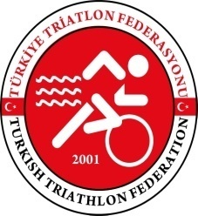 TÜRKİYE TRİATLON FEDERASYONU BAŞKANLIĞI
TURKISH TRIATHLON FEDERATION

26. ALANYA ETU JUNIOR CUP AND ETU EUROPEAN CUP FINAL

Dear National Federations and Triathletes,

Alanya triathlon races which is contiuned 26 years will do this years with the same excitement and success story. Explicit security measures will be taken by our National Federation and district governorship. Also Local Organization Committee is continuing to all preparations.
Antidemocratic attempted coup was prevented. All sports activities are safely complitied.
We look forward to all triathlete and all guests.
With my best regards.

Hamdi GÜNEŞ
President of Turkish Triathlon Federation

