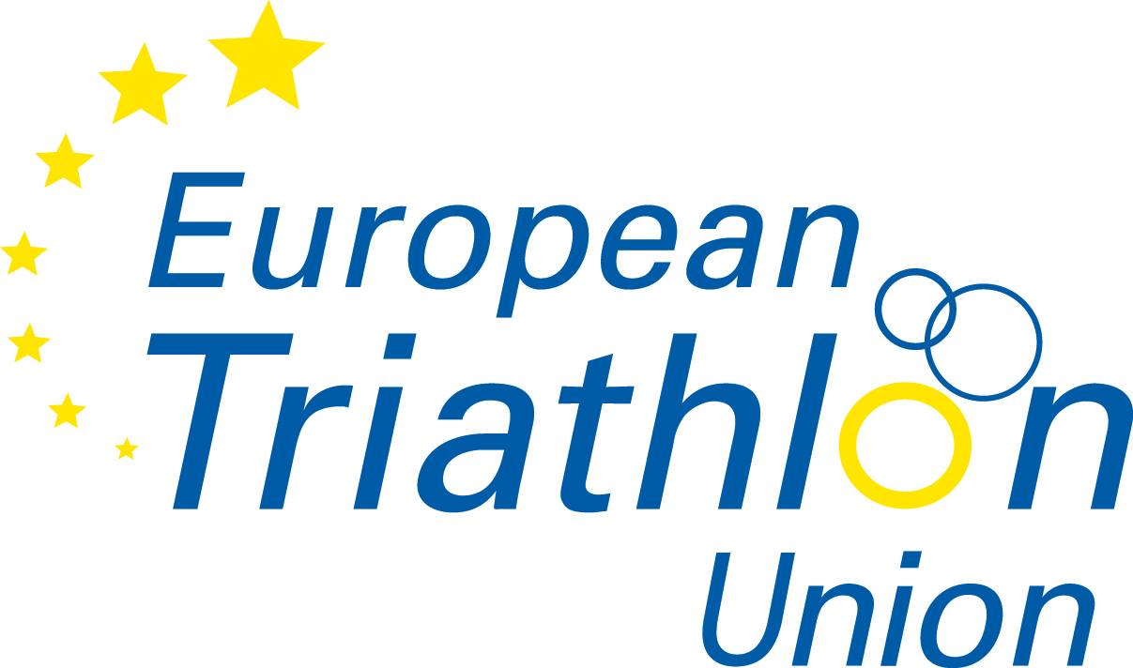
EUROPEAN TRIATHLON UNION

2015 ETU Athlete Prize Money Claim Form

In order to claim prize money from ETU the athlete has to give his/her full and correct address and bank details in clear and legible writing. If incorrect information is provided, a bank transfer of prize money will not be possible. Please note that ETU are only able to pay out prize money after receiving this form from either you, the assigned Technical Official or the Local Organiser.

ETU event:
Beneficiary Name:
Beneficiary Address:
Email address:
Name of Bank :
Bank Address:
IBAN or Account Number:
BSB or Swift number :
Correspondent Bank Swift (if required):
Correspondent Bank IBAN/Account (if required):

To be filled out by ETU official:

Result/rank:__________________ Amount of Prize Money in EUR: ____________

Signature of ETU official: __________________________

Please send this claim form to the ETU office:
for the attention of Kathleen Smet, Kroonstraat, 72, 3581 Beverlo, Belgium
or email it to etu_hq@etu.triathlon.org

