How to snap your ‘100 days to go’ video
On Tuesday 24 April, we will mark 100 days to go until Glasgow2018 with a very special video reflecting the wealth of countries and athletes set to compete at this August’s European Championships.
We need your help!
We’d like as many athletes as possible to send us a quick, mobile phone shot, video of them saying ‘100 days to go until Glasgow 2018’ in their native language.

HOW TO SHOOT/SEND
This can be done in selfie format, or someone else can film. As long as the athlete featured on the video has ambitions to represent their country at this year’s European Championships in Glasgow.
The athlete should say ‘100 days to go’ in their own language. They are also free to say something else after this such as ‘Come on Glasgow’ ‘I can’t wait for it to start’ ‘Good luck Scotland’. Whatever you think will get people excited for our event!
PLEASE FILM IN LANDSCAPE MODE not portrait
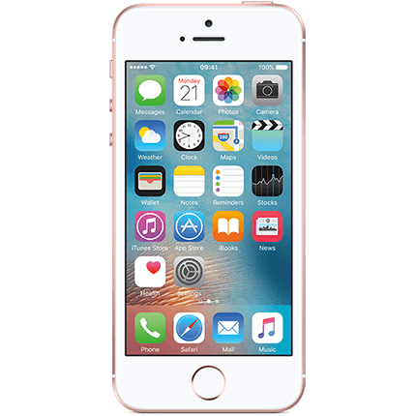

Please keep the clip to a maximum of 7 seconds long.
Once it has been filmed please send using one of the following options (in order of preference):
- Send directly over WhatsApp to (+44) 778 775 4845
- Direct private message to @Glasgow2018 on Twitter
- Email to mark.pryde@glasgow.gov.uk
- WeTransfer to mark.pryde@glasgow.gov.uk
Make sure to send a name and nationality with the video (eg John Smith, UK)
Your details and videos will not be shared with anyone else and will be used for Glasgow 2018 purposes only.

BACKGROUND/LOCATION
If you can, try and film with some sporting equipment or venue in the background. OR try and create a sense of your country (Example, if you’re in Finland let’s try to get the snow in the background).
If you’re at home, don’t worry. This is okay too!

Please send videos to us by Monday 23 April at the latest.

